**Existing Companies**

There are many companies worldwide which host inventory systems for robot parts. In this report, we will analyze some of them in contrast to our XLR8 inventory management system.

RobotWorx is one of these companies which maintains an inventory of robot parts. This company deals in new and used robot parts and their web-based inventory management system displays parts in a catalogue according to different categories and brands. However, although RobotWorx shows the parts in a list with most of the required information, but it does not include pictures of each part along with the description, as shown in Figure 1. This can be confusing for the users as they might not understand which part it is based on just the name of the part. XLR8 inventory system solves this problem by including at least one image for every part in the inventory so that users can quickly get the idea about a part on the first glance.

Figure 1 – RobotWorx Parts List

IRSA is another organization which deals with industrial robots, their parts and service. Their inventory contains a large number of robot spare parts and the website lists the parts according to specific categories. The parts are also grouped by the brand name so the users can choose to browse through parts by selecting a category from within a specific brand. Listing of part information in this system is quite similar to what we have used in XLR8 inventory management system as IRSA also includes pictures of the part and lists down description and features for every part. IRSA website also includes an additional feature where it shows related products when a part is opened for viewing, as shown in Figure 2. This gives the users an additional insight into products that they might need as an alternative or as an additional product.

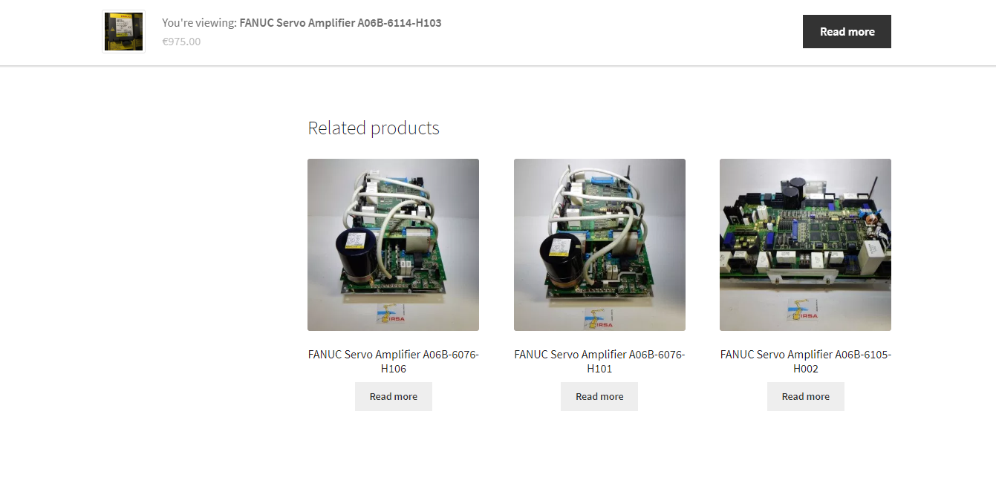

Figure 2 – IRSA Related Products

KC Robotics is another similar company which maintains a large collection of robot parts. This company claims to have robot parts which are hard to find. Apart from their own physical inventory, they have numerous industry partnerships which allows them to find parts which are not available in the general market. However, the KC Robotics inventory website is not very user interactive. Also, it contains a lot of information about the types and brands of parts but does not contain much information about the actual parts individually, which is a drawback in this inventory system (Figure 3). The XLR8 inventory management website is being designed in a way which will make it user interactive and easy to use. Also, it is being made sure that all individual parts are made available to the users for viewing along with descriptions, notes, history, availability and images.

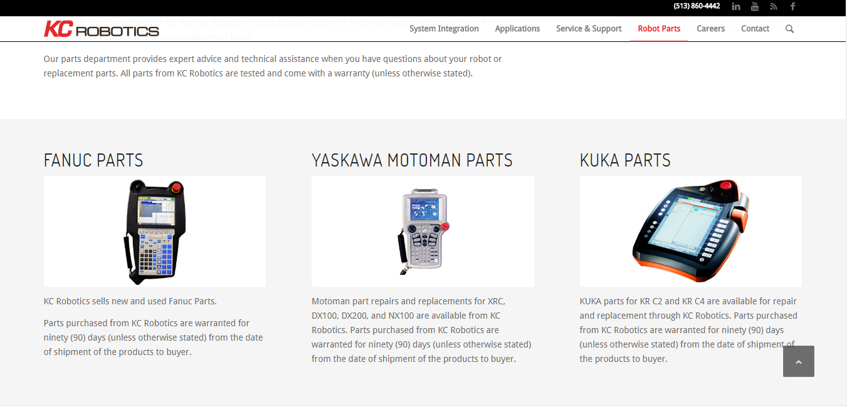

Figure 3 – KC Robotics Main Categories/Brands

**Limitations**

* The companies studied in this report maintain inventories for robot parts, but those robots/parts might not be used in any student competitions
* Database structures of the inventories studied in this report is not known.
* Implementation data, such as the technologies and tools used to develop these web-based inventories in unavailable as the data remains private to those companies.
* Performance of web-based systems like the ones studied in this report can depend on a number of factors such as speed of internet connections, location of database servers and size of inventories.

**References**

RobotWorx 2019, RobotWorx, Scott Technology Ltd, viewed 8 May 2019,

<<https://www.robots.com/>>

IRSA 2018, IRSA, IRSA Robotics, viewed 9 May 2019,

<<https://irsa.store/>>

KC Robotics 2017, KC Robotics, KC Robotics Inc, viewed 9 May 2019,

<<https://www.kcrobotics.com/>>